**Advanced Software Engineering**

**Lab Assignment 2**

**Harish Kolla**

**Class Id: 44**

**Registration Page:**

The user can register on this page by entering the details like Name, Email, Password, Contact no, Street, Address so on which if correct makes the user getting registered.

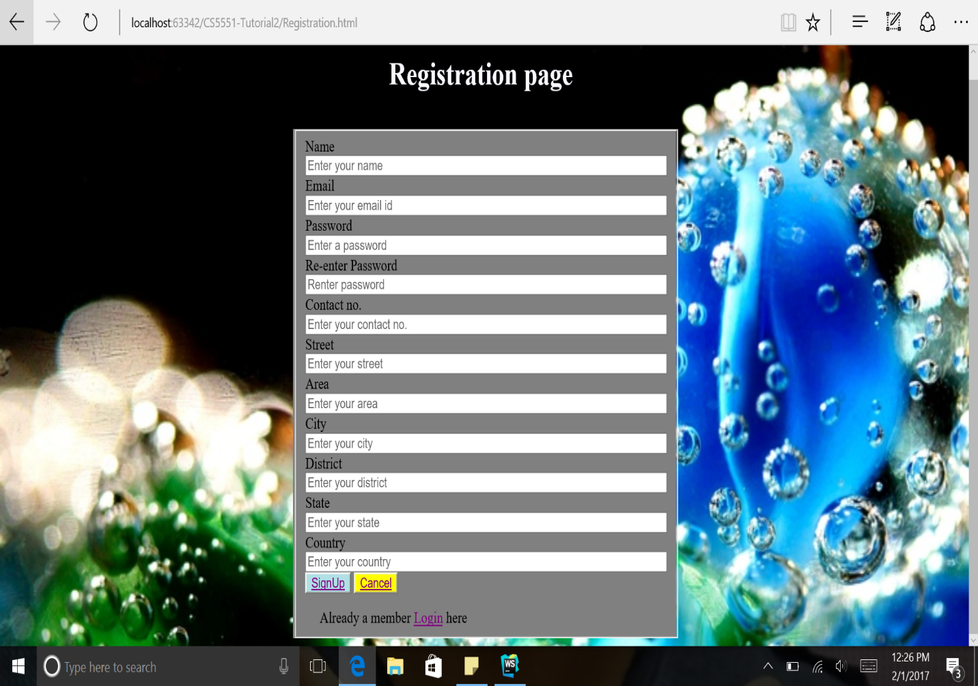

**Registration Success Page:**

This page will be the next page after registration is done.

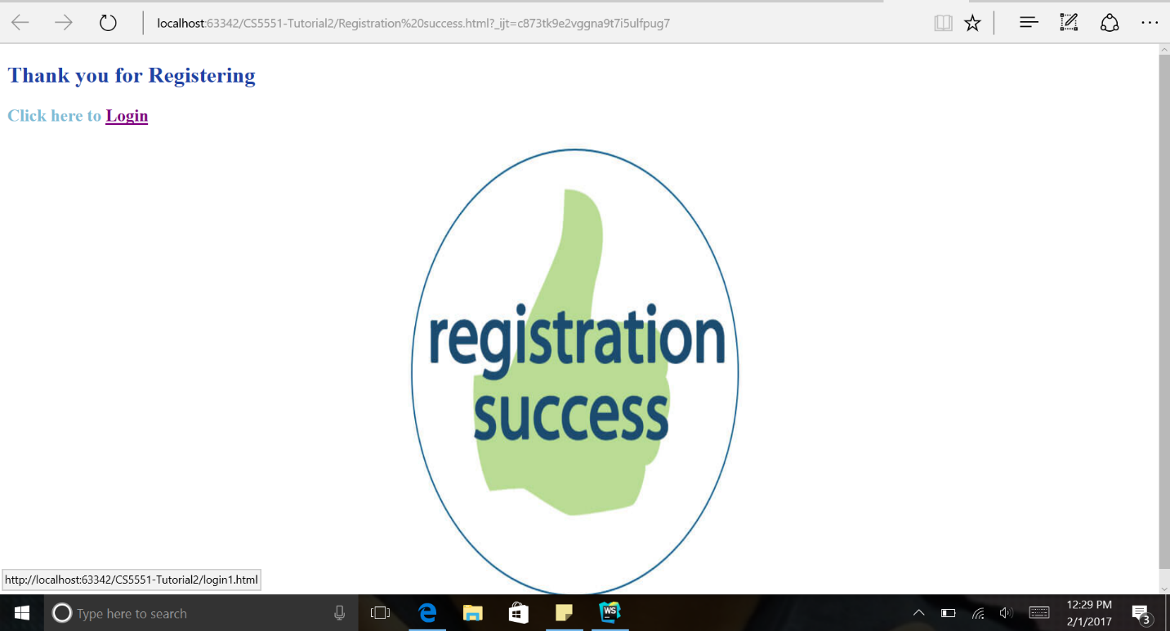

**Login Page:**

After registration if the user enters the right credentials that is the username and password he will be directed to the home page.

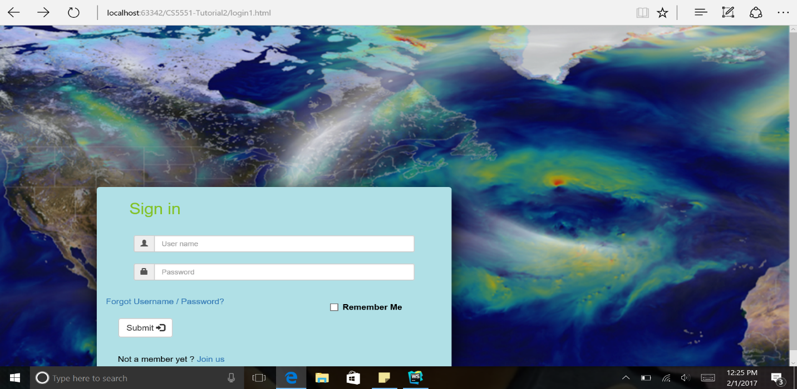

**Home Page:**

This page displays the direction and weather of the place entered.

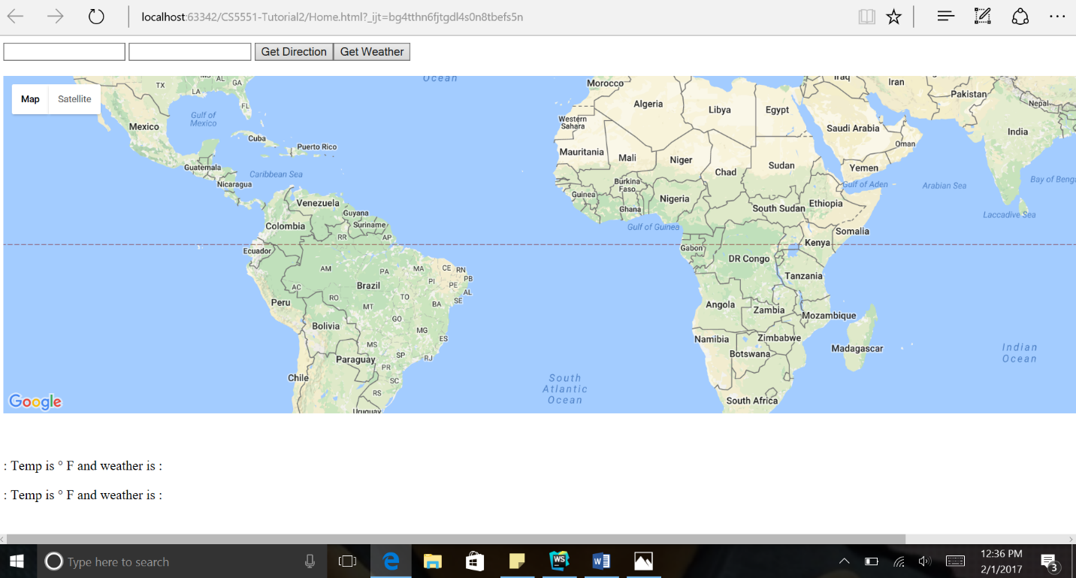

**Directions Page:**

This page shows the direction of the place entered in the home page.

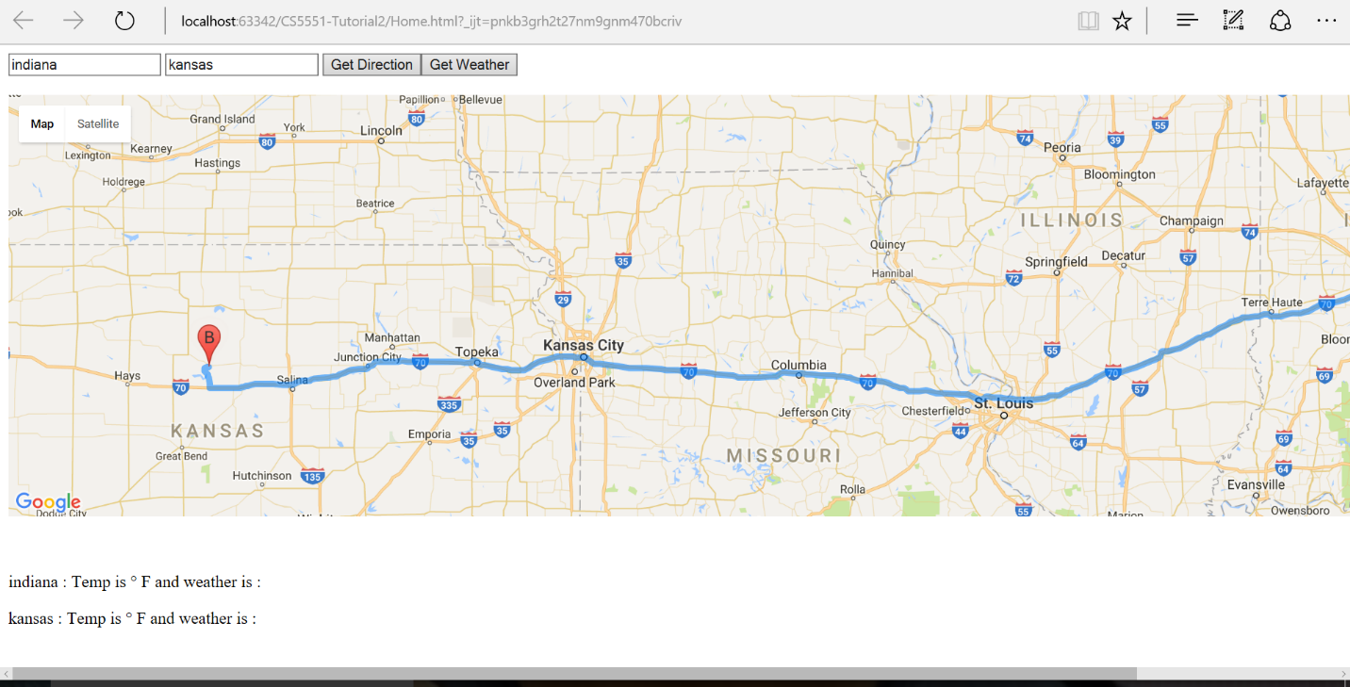

**Weather Page:**

This page displays the weather of cities given in the home page as shown below.

